Lesson 1

Objective: Reason concretely and pictorially using place value understanding to relate adjacent base ten units from millions to thousandths.

Suggested Lesson Structure

|  |  |
| --- | --- |
|  | A NOTE ON  MULTIPLE MEANS  OF ACTION AND  EXPRESSION: |
| Throughout *A Story of Units*, place value language is key. In earlier grades, teachers use units to refer to a number such as 245, as two *hundred* forty-five. Likewise, in Grades 4 and 5, decimals should be read emphasizing their unit form. For example, 0.2 would be read 2 *tenths* rather than *zero point two.* This emphasis on unit language not only strengthens student place value understanding, but it also builds important parallels between whole number and decimal fraction understanding. | |

 Fluency Practice (12 minutes)

 Application Problem (8 minutes)

 Concept Development (30 minutes)

 Student Debrief (10 minutes)

**Total Time (60 minutes)**

Fluency Practice (12 minutes)

* Sprint: Multiply by 10 **4.NBT.1** (8 minutes)
* Rename the Units—Choral Response  **2.NBT.1** (2 minutes)
* Decimal Place Value **4.NF.5–6** (2 minutes)

Sprint: Multiply by 10 (8 minutes)

Materials: (S) Multiply by 10 Sprint

Note: Reviewing this fluency activity will acclimate students to the Sprint routine, a vital component of the fluency program.

|  |  |
| --- | --- |
|  | NOTES ON  FLUENCY PRACTICE: |
| Think of fluency as having three goals:   * Maintenance (staying sharp on previously learned skills). * Preparation (targeted practice for the current lesson). * Anticipation (skills that ensure that students will be ready for the in-depth work of upcoming lessons). | |

Please see Directions for Administration of Sprints in the Module Overview for tips on implementation.

Rename the Units—Choral Response (2 minutes)

Notes: This fluency activity reviews foundations that lead into today’s lesson.

T: (Write 10 ones = _____ ten.) Say the number sentence.

S: 10 ones = 1 ten.

T: (Write 20 ones = _____ tens.) Say the number sentence.

S: 20 ones = 2 tens.

T: 30 ones.

S: 3 tens.

Repeat the process for 80 ones, 90 ones, 100 ones, 110 ones, 120 ones, 170, 270, 670, 640, and 830.

Decimal Place Value (2 minutes)

Materials: (S) Personal white board, unlabeled hundreds to hundredths place value chart (Template 1)

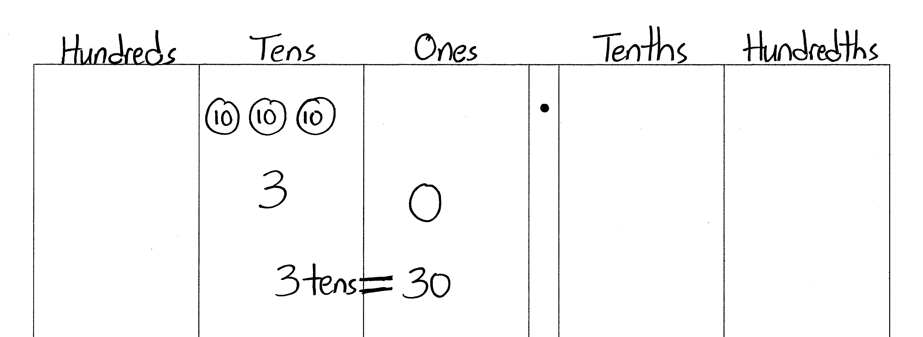Note: Reviewing this Grade 4 topic lays a foundation for students to better understand place value to bigger and smaller units.

T: (Project unlabeled hundreds to hundredths place value chart. Draw 3 ten disks in the tens column.) How many tens do you see?

S: 3 tens.

T: (Write 3 underneath the disks.) There are 3 tens and how many ones?

S: Zero ones.

T: (Write 0 in the ones column. Below it, write 3 tens = ___.) Fill in the blank.

S: 3 tens = 30.

Repeat the process for 3 tenths = 0.3.

T: (Write 4 tenths = ___.) Show the answer in your place value chart.

S: (Draw four 1 tenth disks. Below it, write 0.4.)

Repeat the process for 3 hundredths, 43 hundredths, 5 hundredths, 35 hundredths, 7 ones 35 hundredths,   
9 ones 24 hundredths, and 6 tens 2 ones 4 hundredths.

Note: Place value disks are used as models throughout the curriculum and can be represented in two different ways. A disk with a value labeled inside of it (above) should be drawn or placed on a place value chart with no headings. The value of the disk in its appropriate column indicates the column heading. A place value disk drawn as a dot should be used on place value charts *with* headings, as shown in Problem 1 of Concept Development. The dot is a faster way to represent the place value disk and is used as students move further away from a concrete stage of learning.

Application Problem (8 minutes)

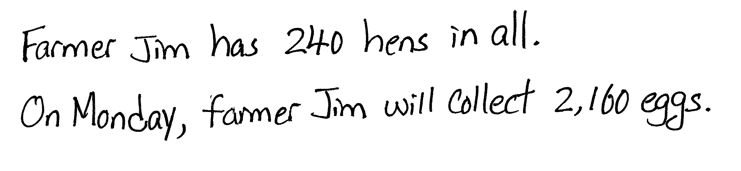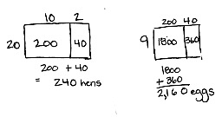

Farmer Jim keeps 12 hens in every coop. If Farmer Jim has 20 coops, how many hens does he have in all? If every hen lays 9 eggs on Monday, how many eggs will Farmer Jim collect on Monday? Explain your reasoning using words, numbers, or pictures.

Note: This problem is intended to activate prior knowledge from Grade 4 and offer a successful start to Grade 5. Some students may use area models to solve, while others may choose to use the standard algorithm. Still others may draw tape diagrams to show their thinking. Allow students to share work and compare approaches.

Concept Development (30 minutes)

Materials: (S) Millions through thousandths place value chart (Template 2), personal white board

The place value chart and its *times 10* relationships are familiar territory for students. New learning in   
Grade 5 focuses on understanding a new fractional unit of *thousandths* as well as the decomposition of larger units to those that are 1 tenthas large. Building the place value chart from right (tenths) to left (millions) before beginning the following problem sequence may be advisable. Encourage students to multiply and then bundle to form the next largest place (e.g., 10 $×$ 1 hundred = 10 hundreds, which can be bundled to form 1 thousand).

Problem 1: Divide single units by 10 to build the place value chart to introduce thousandths*.*

T: Slide your millions through thousandths place value chart into your personal white board. Show 1 million, using disks, on the place value chart.

S: (Work.)

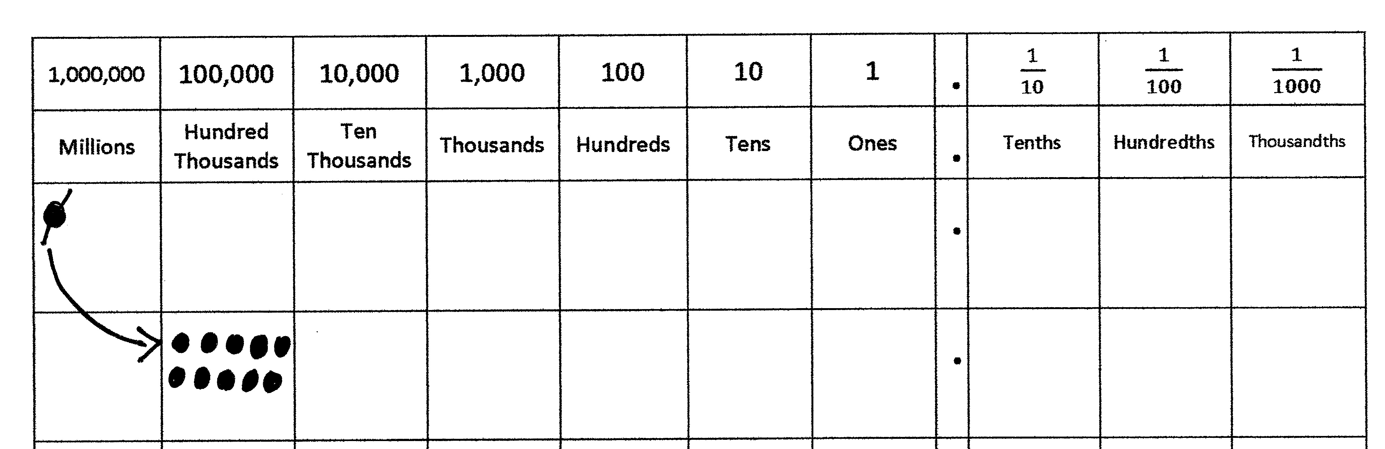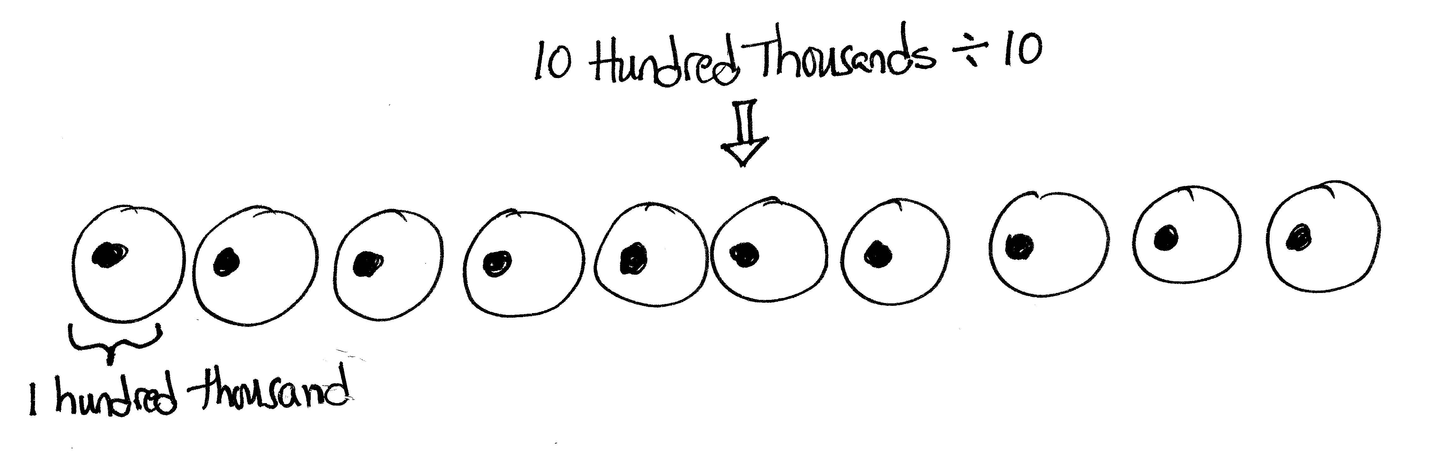

T: How can we show 1 million using hundred thousands? Work with your partner to show this on your chart.

S: 1 million is the same as 10 hundred thousands.

T: What is the result if I divide 10 hundred thousands by 10? Talk with your partner, and use your chart to find the quotient.

T: (Circulate.) I saw that David put 10 disks in the hundred thousands place and then distributed them into 10 equal groups. How many are in each   
group?

S: When I divide 10 hundred thousands by 10, I get 1 hundred thousand in each group.

T: Let me record what I hear you saying. (Record on class board.)

*10 hundred thousands ÷ 10 = 1 hundred thousands 1 million ÷ 10 = 1 hundred thousand*

*1 hundred thousand is $\frac{1}{10}$ as large as 1 million.*

|  |  |  |  |  |  |  |  |  |  |
| --- | --- | --- | --- | --- | --- | --- | --- | --- | --- |
| Millions  ÷10 | Hundred  Thousands | Ten  Thousands | Thousands | Hundreds | Tens | Ones | Tenths | Hundredths | Thousandths |
| 1 |  |  |  |  |  |  |  |  |  |
|  | 1 |  |  |  |  |  |  |  |  |

T: Draw 1 hundred thousands disk on your chart. What is the result if we divide 1 hundred thousand by 10? Show this on your chart and write a division sentence.

Continue this sequence until the hundredths place is reached, emphasizing the unbundling for 10 of the smaller unit and then the division. Record the place values and equations (using unit form) on the board being careful to point out the *1 tenth as large* relationship:

|  |  |
| --- | --- |
|  | NOTES ON  MULTIPLE MEANS  OF ENGAGEMENT: |
| Students who have limited experience with decimal fractions may be supported by a return to Grade 4’s Module 6 to review decimal place value and symmetry with respect to the ones place.  Conversely, student understanding of decimal fraction place value units may be extended by asking for predictions of units one-tenth as large as the thousandths place and those beyond. | |

1 million ÷ 10 = 1 hundred thousand

1 hundred thousand ÷ 10 = 1 ten thousand

1 ten thousand ÷ 10 = 1 thousand

1 thousand ÷ 10 = 1 hundred

(Continue through 1 tenth ÷ 10 = 1 hundredth.)

T: What patterns do you notice in the way the units are named in our place value system?

**MP.8**

S: The ones place is the middle. There are tens on the left and tenths on the right, hundreds on the left and hundredths on the right.

|  |  |
| --- | --- |
|  | NOTES ON  MULTIPLE MEANS  OF ENGAGEMENT: |
| Proportional materials such as base ten blocks can help English language learners distinguish between place value labels like *hundredth* and *thousandth* more easily by offering clues to their relative sizes. These students can be encouraged to name the units in their first language and then compare them to their English counterparts. Sometimes the roots of these number words are very similar. These parallels enrich the experience and understanding of all students. | |

T: (Point to the chart.) Using this pattern, can you predict what the name of the unit that is to the right of the hundredths place (1 tenth as large as hundredths) might be?

S: (Share. Label the thousandths place.)

T: Think about the pattern that we’ve seen with other adjacent places. Talk with your partner and predict how we might show 1 hundredth using thousandths disks. Show this on your chart.

S: Just like all the other places, it takes 10 of the smaller unit to make 1 of the larger, so it will take 10 thousandths to make 1 hundredth.

T: Use your chart to show the result if we divide 1 hundredth by 10, and write the division sentence.

S: (Share.)

T: (Add this equation to the others on the board.)

Problem 2: Multiply copies of one unit by 10, 100, and 1,000.



0.4 $×$ 10

0.04 $×$ 10

0.004 $×$ 10

T: Use digits to represent 4 tenths at the top of your place value chart.

S: (Write.)

T: Work with your partner to find the value of 10 times 0.4. Show your result at the bottom of your place value chart.

S: 4 tenths $×$ 10 = 40 tenths, which is the same as 4 wholes. 🡪 4 ones is 10 times as large as 4 tenths.

T: On your place value chart, use arrows to show how the value of the digits has changed.   
(On the place value chart, draw an arrow to indicate the shift of the digit to the left, and write $×$ 10 near the arrow.)

T: Why does the digit move one place to the left?

S: Because it is 10 times as large, it has to be bundled for the next larger unit.

Repeat with 0.04 $×$ 10 and 0.004 $×$ 1,000. Use unit form to state each problem, and encourage students to articulate how the value of the digit changes and why it changes position in the chart.

Problem 3: Divide copies of one unit by 10, 100, and 1,000.

6 ÷ 10

6 ÷ 100

6 ÷ 1,000

Follow a similar sequence to guide students in articulating changes in value and shifts in position while showing it on the place value chart.

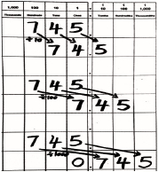

Repeat with 0.7 ÷ 10, 0.7 ÷ 100, and 0.05 ÷ 10.

Problem 4: Multiply mixed units by 10, 100, and 1,000.

2.43 $×$ 10

2.43 $×$ 100

2.43 $×$ 1,000

T: Write the digits two and forty-three hundredths on your place value chart, and multiply by 10, then 100, and then 1,000. Compare these products with your partner.

Lead students to discuss how the digits shift as a result of their change in value by isolating one digit, such as the 3, and comparing its value in each product.

Problem 5

745 ÷ 10

745 ÷ 100

745 ÷ 1,000

Engage in a similar discussion regarding the shift and change in value for a digit in these division problems. See discussion above.

Problem Set (10 minutes)

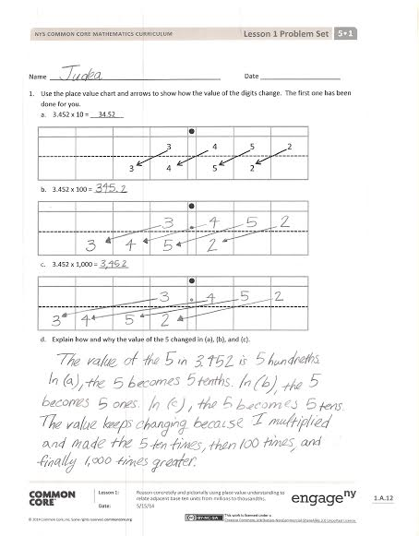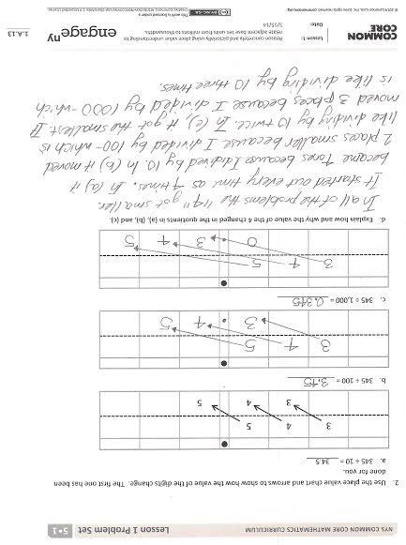

Students should do their personal best to complete the Problem Set within the allotted 10 minutes. Some problems do not specify a method for solving. This is an intentional reduction of scaffolding that invokes MP.5, Use Appropriate Tools Strategically. Students should solve these problems using the RDW approach used for Application Problems.

For some classes, it may be appropriate to modify the assignment by specifying which problems students should work on first. With this option, let the purposeful sequencing of the Problem Set guide the selections so that problems continue to be scaffolded. Balance word problems with other problem types to ensure a range of practice. Consider assigning incomplete problems for homework or at another time during the day.

Student Debrief (10 minutes)

**Lesson Objective:** Reason concretely and pictorially using place value understanding to relate adjacent base ten units from millions to thousandths.

The Student Debrief is intended to invite reflection and active processing of the total lesson experience.

Invite students to review their solutions for the Problem Set. They should check work by comparing answers with a partner before going over answers as a class. Look for misconceptions or misunderstandings that can be addressed in the Debrief. Guide students in a conversation to debrief the Problem Set and process the lesson.

Any combination of the questions below may be used to lead the discussion.

* Compare the solutions you found when multiplying by 10 and dividing by 10 (3.452 $×$ 10 and 345 ÷ 10). How do the solutions of these two expressions relate to the value of the original quantity? How do they relate to each other?
* 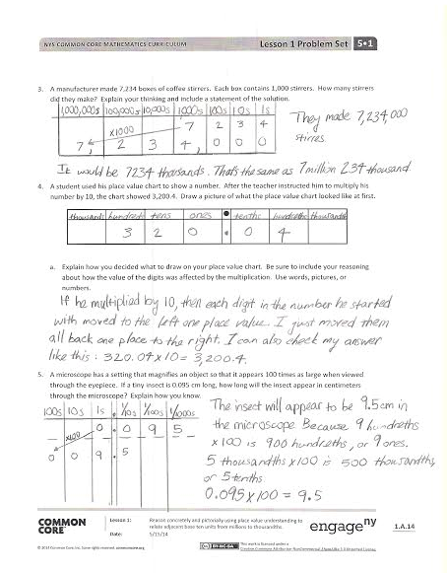What do you notice about the number of zeros in your products when multiplying by 10, 100, and 1,000 relative to the number of places the digits shift on the place value chart? What patterns do you notice?
* What is the same and what is different about the products for Problems 1(a), 1(b), and 1(c)? (Encourage students to notice that the digits are exactly the same. Only the values have changed.)
* When solving Problem 2(c), many of you noticed the use of our new place value. (Lead a brief class discussion to reinforce what value this place represents. Reiterate the symmetry of the places on either side of the ones place and the size of *thousandths* relative to other place values like tenths and ones.)

Exit Ticket (3 minutes)

After the Student Debrief, instruct students to complete the Exit Ticket. A review of their work will help with assessing students’ understanding of the concepts that were presented in today’s lesson and planning more effectively for future lessons. The questions may be read aloud to the students.

Number Correct: _______

**A**

Multiply by 10

|  |  |  |  |  |  |  |
| --- | --- | --- | --- | --- | --- | --- |
|  | 12 × 10 = |  |  |  | 34 × 10 = |  |
|  | 14 × 10 = |  |  |  | 134 × 10 = |  |
|  | 15 × 10 = |  |  |  | 234 × 10 = |  |
|  | 17 × 10 = |  |  |  | 334 × 10 = |  |
|  | 81 × 10 = |  |  |  | 834 × 10 = |  |
|  | 10 × 81 = |  |  |  | 10 × 834 = |  |
|  | 21 × 10 = |  |  |  | 45 × 10 = |  |
|  | 22 × 10 = |  |  |  | 145 × 10 = |  |
|  | 23 × 10 = |  |  |  | 245 × 10 = |  |
|  | 29 × 10 = |  |  |  | 345 × 10 = |  |
|  | 92 × 10 = |  |  |  | 945 × 10 = |  |
|  | 10 × 92 = |  |  |  | 56 × 10 = |  |
|  | 18 × 10 = |  |  |  | 456 × 10 = |  |
|  | 19 × 10 = |  |  |  | 556 × 10 = |  |
|  | 20 × 10 = |  |  |  | 950 × 10 = |  |
|  | 30 × 10 = |  |  |  | 10 × 950 = |  |
|  | 40 × 10 = |  |  |  | 16 × 10 = |  |
|  | 80 × 10 = |  |  |  | 10 × 60 = |  |
|  | 10 × 80 = |  |  |  | 493 × 10 = |  |
|  | 10 × 50 = |  |  |  | 10 × 84 = |  |
|  | 10 × 90 = |  |  |  | 96 × 10 = |  |
|  | 10 × 70 = |  |  |  | 10 × 580 = |  |

**B**

**[KEY]**

Number Correct: _______

Improvement: _______

Multiply by 10

|  |  |  |  |  |  |  |
| --- | --- | --- | --- | --- | --- | --- |
|  | 13 × 10 = |  |  |  | 43 × 10 = |  |
|  | 14 × 10 = |  |  |  | 143 × 10 = |  |
|  | 15 × 10 = |  |  |  | 243 × 10 = |  |
|  | 19 × 10 = |  |  |  | 343 × 10 = |  |
|  | 91 × 10 = |  |  |  | 743 × 10 = |  |
|  | 10 × 91 = |  |  |  | 10 × 743 = |  |
|  | 31 × 10 = |  |  |  | 54 × 10 = |  |
|  | 32 × 10 = |  |  |  | 154 × 10 = |  |
|  | 33 × 10 = |  |  |  | 254 × 10 = |  |
|  | 38 × 10 = |  |  |  | 354 × 10 = |  |
|  | 83 × 10 = |  |  |  | 854 × 10 = |  |
|  | 10 × 83 = |  |  |  | 65 × 10 = |  |
|  | 28 × 10 = |  |  |  | 465 × 10 = |  |
|  | 29 × 10 = |  |  |  | 565 × 10 = |  |
|  | 30 × 10 = |  |  |  | 960 × 10 = |  |
|  | 40 × 10 = |  |  |  | 10 × 960 = |  |
|  | 50 × 10 = |  |  |  | 17 × 10 = |  |
|  | 90 × 10 = |  |  |  | 10 × 70 = |  |
|  | 10 × 90 = |  |  |  | 582 × 10 = |  |
|  | 10 × 20 = |  |  |  | 10 × 73 = |  |
|  | 10 × 60 = |  |  |  | 98 × 10 = |  |
|  | 10 × 80 = |  |  |  | 10 × 470 = |  |

Name Date

1. Use the place value chart and arrows to show how the value of the each digit changes. The first one has been done for you.
2. 3.452 × 10 = 34.52

|  |  |  |  |  |  |  |  |
| --- | --- | --- | --- | --- | --- | --- | --- |
|  |  |  |  |  |  |  |  |
|  |  |  | 3 |  | 4 | 5 | 2 |
|  |  | 3 | 4 |  | 5 | 2 |  |

1. 3.452 × 100 = _________

|  |  |  |  |  |  |  |  |
| --- | --- | --- | --- | --- | --- | --- | --- |
|  |  |  |  |  |  |  |  |
|  |  |  |  |  |  |  |  |
|  |  |  |  |  |  |  |  |

1. 3.452 × 1,000 = ________

|  |  |  |  |  |  |  |  |
| --- | --- | --- | --- | --- | --- | --- | --- |
|  |  |  |  |  |  |  |  |
|  |  |  |  |  |  |  |  |
|  |  |  |  |  |  |  |  |

1. Explain how and why the value of the 5 changed in (a), (b), and (c).
2. Use the place value chart and arrows to show how the value of each digit changes. The first one has been done for you.
3. 345 ÷ 10 = 34.5

|  |  |  |  |  |  |  |  |
| --- | --- | --- | --- | --- | --- | --- | --- |
|  |  |  |  |  |  |  |  |
|  | 3 | 4 | 5 |  |  |  |  |
|  |  | 3 | 4 |  | 5 |  |  |

1. 345 ÷ 100 = ____________

|  |  |  |  |  |  |  |  |
| --- | --- | --- | --- | --- | --- | --- | --- |
|  |  |  |  |  |  |  |  |
|  |  |  |  |  |  |  |  |
|  |  |  |  |  |  |  |  |

1. 345 ÷ 1,000 = _____________

|  |  |  |  |  |  |  |  |
| --- | --- | --- | --- | --- | --- | --- | --- |
|  |  |  |  |  |  |  |  |
|  |  |  |  |  |  |  |  |
|  |  |  |  |  |  |  |  |

1. Explain how and why the value of the 4 changed in the quotients in (a), (b), and (c).
2. A manufacturer made 7,234 boxes of coffee stirrers. Each box contains 1,000 stirrers. How many stirrers did they make? Explain your thinking, and include a statement of the solution.
3. A student used his place value chart to show a number. After the teacher instructed him to multiply his number by 10, the chart showed 3,201.4. Draw a picture of what the place value chart looked like at first.

|  |  |  |  |  |  |  |  |
| --- | --- | --- | --- | --- | --- | --- | --- |
|  |  |  |  |  |  |  |  |
|  |  |  |  |  |  |  |  |

Explain how you decided what to draw on your place value chart. Be sure to include your reasoning about how the value of each digit was affected by the multiplication. Use words, pictures, or numbers.

1. A microscope has a setting that magnifies an object so that it appears 100 times as large when viewed through the eyepiece. If a tiny insect is 0.095 cm long, how long will the insect appear in centimeters through the microscope? Explain how you know.

Name Date

Use the place value chart and arrows to show how the value of each digit changes.

* 1. 6.671 × 100 = ____________

|  |  |  |  |  |  |  |  |
| --- | --- | --- | --- | --- | --- | --- | --- |
|  |  |  |  |  |  |  |  |
|  |  |  |  |  |  |  |  |
|  |  |  |  |  |  |  |  |

* 1. 684 ÷ 1,000 = ____________

|  |  |  |  |  |  |  |  |
| --- | --- | --- | --- | --- | --- | --- | --- |
|  |  |  |  |  |  |  |  |
|  |  |  |  |  |  |  |  |
|  |  |  |  |  |  |  |  |

Name Date

1. Use the place value chart and arrows to show how the value of each digit changes. The first one has been done for you.
2. 4.582 × 10 = 45.82

|  |  |  |  |  |  |  |  |
| --- | --- | --- | --- | --- | --- | --- | --- |
|  |  |  |  |  |  |  |  |
|  |  |  | 4 |  | 5 | 8 | 2 |
|  |  | 4 | 5 |  | 8 | 2 |  |

1. 7.281 × 100 = ____________

|  |  |  |  |  |  |  |  |
| --- | --- | --- | --- | --- | --- | --- | --- |
|  |  |  |  |  |  |  |  |
|  |  |  |  |  |  |  |  |
|  |  |  |  |  |  |  |  |

1. 9.254 × 1,000 = ____________

|  |  |  |  |  |  |  |  |
| --- | --- | --- | --- | --- | --- | --- | --- |
|  |  |  |  |  |  |  |  |
|  |  |  |  |  |  |  |  |
|  |  |  |  |  |  |  |  |

1. Explain how and why the value of the 2 changed in (a), (b), and (c).
2. Use the place value chart and arrows to show how the value of each digit changes. The first one has been done for you.
3. 2.46 ÷ 10 = 0.246

|  |  |  |  |  |  |  |  |
| --- | --- | --- | --- | --- | --- | --- | --- |
|  |  |  |  |  |  |  |  |
|  |  |  | 2 |  | 4 | 6 |  |
|  |  |  |  |  | 2 | 4 | 6 |

1. 678 ÷ 100 = ____________

|  |  |  |  |  |  |  |  |
| --- | --- | --- | --- | --- | --- | --- | --- |
|  |  |  |  |  |  |  |  |
|  |  |  |  |  |  |  |  |
|  |  |  |  |  |  |  |  |

1. 67 ÷ 1,000 = ____________

|  |  |  |  |  |  |  |  |
| --- | --- | --- | --- | --- | --- | --- | --- |
|  |  |  |  |  |  |  |  |
|  |  |  |  |  |  |  |  |
|  |  |  |  |  |  |  |  |

1. Explain how and why the value of the 6 changed in the quotients in (a), (b), and (c).
2. Researchers counted 8,912 monarch butterflies on one branch of a tree at a site in Mexico. They estimated that the total number of butterflies at the site was 1,000 times as large. About how many butterflies were at the site in all? Explain your thinking, and include a statement of the solution.
3. A student used his place value chart to show a number. After the teacher instructed him to divide his number by 100, the chart showed 28.003. Draw a picture of what the place value chart looked like at first.

|  |  |  |  |  |  |  |  |
| --- | --- | --- | --- | --- | --- | --- | --- |
|  |  |  |  |  |  |  |  |
|  |  |  |  |  |  |  |  |

Explain how you decided what to draw on your place value chart. Be sure to include reasoning about how the value of each digit was affected by the division.

1. On a map, the perimeter of a park is 0.251 meters. The actual perimeter of the park is 1,000 times as large. What is the actual perimeter of the park? Explain how you know using a place value chart.

|  |
| --- |
|  |
|  |
| ** •** |
|  |
|  |
|  |

[1]

|  |  |  |  |  |  |  |  |  |  |  |
| --- | --- | --- | --- | --- | --- | --- | --- | --- | --- | --- |
| 1,000,000 | 100,000 | 10,000 | 1,000 | 100 | 10 | 1 | . | $\frac{1}{10}$ | $\frac{1}{100}$ | $\frac{1}{1000}$ |
| Millions | Hundred  Thousands | Ten  Thousands | Thousands | Hundreds | Tens | Ones | . | Tenths | Hundredths | Thousandths |
|  |  |  |  |  |  |  | . |  |  |  |
|  |  |  |  |  |  |  | . |  |  |  |
|  |  |  |  |  |  |  | . |  |  |  |
|  |  |  |  |  |  |  |  |  |  |  |
|  |  |  |  |  |  |  |  |  |  |  |
|  |  |  |  |  |  |  |  |  |  |  |
|  |  |  |  |  |  |  |  |  |  |  |
|  |  |  |  |  |  |  |  |  |  |  |
|  |  |  |  |  |  |  |  |  |  |  |
|  |  |  |  |  |  |  |  |  |  |  |

[2]

1. unlabeled hundreds through hundredths place value chart
2. millions through thousandths place value chart